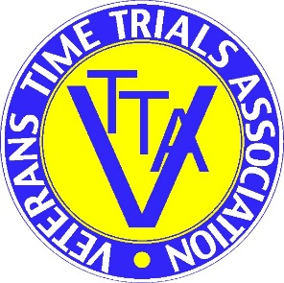
VTTA YORKSHIRE GROUP OPEN 25 MILE TIME TRAIL
Promoted for and on behalf of Cycling Time Trails under there Rule and Regulations
OFFICAL RESULT SHEET
Sunday 18th April 2021
Event Organiser
Blair Buss
6 Bramley View, Lightcliffe, Hipperholme, Halifax, HX38ST
Telephone – 01422 202957 or 07936146533
e-mail – blairbuss@btinternet.com

Awards

Best on standard and Winner of the Bernard Wood Memorial Shield.
Russ Richardson + 16:04
Second on standard Darren Yarwood and Winner of the Oliver Shield + 15:04
Third on standard Tim Garwell + 14:50

Actual Times (Male)
Winner Alexander Royle 49:56
Second Richard Sharp 50:22
Third Ben Stead 51:22

Actual Times (Female)
Winner Abi Smith 55:34
Second Louise Scupham 1:00:25
Third Hannah Bayes 1:00:47

Age Group Winners on Standards

40 - 49 Male 1st Matthew Asqwith 2nd Matt Smith 3rd Greg Elwell
40 - 49 Female 1st Sarah Harrison 2nd Sarah Foulds
50 - 59 Male 1st Jim Boyle 2nd Michael Cross 3rd Sean Sanders
50 - 59 Female 1st Karen Taylor 2nd Sandra Burrows
60 - 69 Male 1st David Taylor 2nd Christopher Green 3rd Stephen L’Anson
60 - 69 Female 1st Liz Ball
70 - 79 Male 1st Lee Foster 2nd Peter Macklam 3rd Mike Cole

Medium Gear 1st Blair Buss 2nd Jymmy Trevor
One rider one prize

https://www.kimroy-photography.co.uk/shop3_gallery/

